Victims of Credit Card Fraud and other Identity Theft

- Cleaning the data :
The data has NA/Missing values. Hence the first step was to clean the data by removing all the NA values from the data.
As Clustering requires the data to be converted to numeric form we first get all the character variables, convert them to categorical (factor) values and then convert them to numeric for our algorithm to run smoothly.
Lastly, we removed two columns from the data (ID, Date) as they are not required.

library(readr)
mydata <- read_csv("C:/Users/Downloads/data.csv")

names(which(sapply(mydata, anyNA)))
mydata=na.omit(mydata)

mydata$Victim_Cat <- as.factor(mydata$Victim_Cat)
mydata$Dwelling <- as.factor(mydata$Dwelling)
mydata$City_Rural <- as.factor(mydata$City_Rural)
mydata$Dwelling <- as.factor(mydata$Dwelling)
mydata$City_Rural <- as.factor(mydata$City_Rural)
mydata$Computer <- as.factor(mydata$Computer)
mydata$Tablet <- as.factor(mydata$Tablet)
mydata$Cell_Phone <- as.factor(mydata$Cell_Phone)
mydata$HH_Income <- as.factor(mydata$HH_Income)
mydata$Social_Net <- as.factor(mydata$Social_Net)
mydata$Social_Net_Acct <- as.factor(mydata$Social_Net_Acct)

mydata$Victim_Cat <- as.numeric(mydata$Victim_Cat)
mydata$Dwelling <- as.numeric(mydata$Dwelling)
mydata$City_Rural <- as.numeric(mydata$City_Rural)
mydata$Dwelling <- as.numeric(mydata$Dwelling)
mydata$City_Rural <- as.numeric(mydata$City_Rural)
mydata$Computer <- as.numeric(mydata$Computer)
mydata$Tablet <- as.numeric(mydata$Tablet)
mydata$Cell_Phone <- as.numeric(mydata$Cell_Phone)
mydata$HH_Income <- as.numeric(mydata$HH_Income)
mydata$Social_Net <- as.numeric(mydata$Social_Net)
mydata$Social_Net_Acct <- as.numeric(mydata$Social_Net_Acct)

mydata <- mydata[,-6] #Removing date column
mydata <- mydata[,-1]#Removing ID

- Determine the optimal number of clusters:
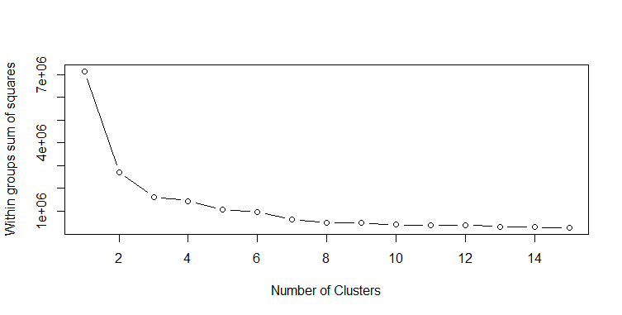
Here, we can see the ratio steadily decreases after k=6. This means for k=4 to k=6 would be a good choice. Thus we take the optimal number to be 5.

library(cluster)
# Determine number of clusters
wss <- (nrow(mydata)-1)*sum(apply(mydata,2,var), na.rm = T)
for (i in 2:15)
{
wss[i] <- sum(kmeans(mydata, centers=i)$withinss)
}

plot(1:15, wss, type="b", xlab="Number of Clusters", ylab="Within groups sum of squares")

- Fit the cluster:
# K-Means Cluster Analysis
fit <- kmeans(mydata, 5)
# get cluster means
aggregate(mydata,by=list(fit$cluster),FUN=mean)
# append cluster assignment
mydata <- data.frame(mydata, fit$cluster)

- Hierarchical Agglomerative cluster :
# Ward Hierarchical Clustering
d <- dist(mydata, method = "euclidean") # distance matrix
fit <- hclust(d, method="ward")
plot(fit) # display dendogram
groups <- cutree(fit, k=5) # cut tree into 5 clusters
# draw dendogram with red borders around the 5 clusters
rect.hclust(fit, k=5, border="red")

